LAB EXPERIMENT RECORD

SET 26: STUDENT PERFORMANCE ANALYSIS

Particulars | Details
Department | AIDS
Course Code / Course Name | DSA0206/ Data Handling and Visualization
Experiment | Data Visualization using R
Name | M V Raghavan
Register Number | 192424373
Date | 15 OCTOBER 2026
Day | Thursday

Aim
To analyze student academic performance using a study-hours versus mathematics-score scatter plot, a science-score boxplot by gender, and a monthly average mathematics-score trend.

Dataset: Student Mini Data
Student ID | Gender | Study Hours | Attendance | Math Score | Science Score | Exam Date
S01 | Male | 2.0 | 78 | 62 | 65 | 2025-01-10
S02 | Female | 3.5 | 90 | 80 | 85 | 2025-01-10
S03 | Male | 1.5 | 70 | 55 | 58 | 2025-02-12
S04 | Female | 4.0 | 95 | 90 | 92 | 2025-02-12
S05 | Male | 2.8 | 85 | 72 | 74 | 2025-03-15
S06 | Female | 3.0 | 92 | 82 | 86 | 2025-03-15

PROGRAM 1: Study Hours vs Mathematics Scores
To examine the relationship between study hours and mathematics scores using a scatter plot, regression line, and correlation coefficient.
# SET 26 - PROGRAM 1
data <- data.frame(
Student_ID = c("S01", "S02", "S03", "S04", "S05", "S06"),
Gender = c("Male", "Female", "Male", "Female", "Male", "Female"), Study_Hours = c(2.0, 3.5, 1.5, 4.0, 2.8, 3.0),
Attendance = c(78, 90, 70, 95, 85, 92),
Math_Score = c(62, 80, 55, 90, 72, 82),
Science_Score = c(65, 85, 58, 92, 74, 86)
)

point_colors <- ifelse(data$Gender == "Male", "blue", "red") plot(data$Study_Hours, data$Math_Score,
main = "Study Hours vs Math Scores",
xlab = "Study Hours", ylab = "Math Score", pch = 19, col = point_colors,
xlim = range(data$Study_Hours), ylim = range(data$Math_Score))
text(data$Study_Hours, data$Math_Score,
labels = data$Student_ID, pos = 3, cex = 0.8) abline(lm(Math_Score ~ Study_Hours, data = data),
col = "darkgreen", lwd = 2) legend("topleft",
legend = c("Male", "Female", "Regression Line"), col = c("blue", "red", "darkgreen"),
pch = c(19, 19, NA), lty = c(NA, NA, 1), bty = "n") correlation <- cor(data$Study_Hours, data$Math_Score) cat("Correlation between Study Hours and Math Scores:",
round(correlation, 3), "\n")

Procedure: Plot study hours on the x-axis and mathematics scores on the y-axis. Label each point with the student ID, add a linear regression line, and calculate the Pearson correlation.
Observation / Result: The correlation is approximately 0.973, indicating a strong positive relationship in this six-student dataset. Students who studied more hours generally had higher mathematics scores. This is an association, not proof that study time alone caused the score differences.
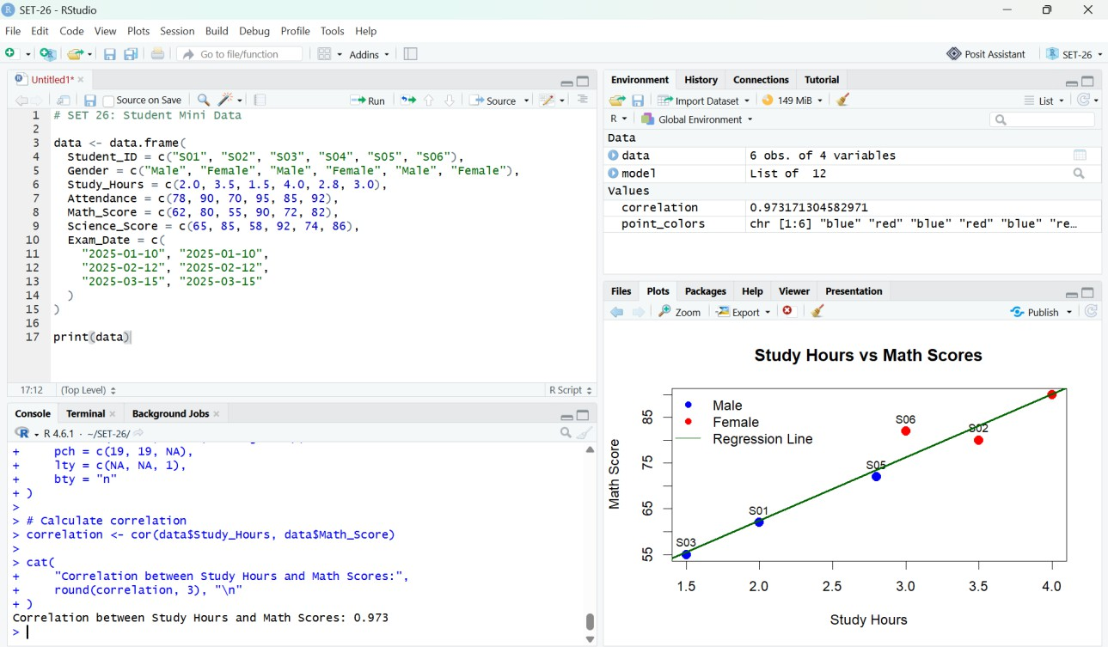
Figure 1. RStudio output: study hours versus mathematics scores with regression line.

PROGRAM 2: Science Scores by Gender
To compare the distribution of science scores for male and female students using boxplots and summary statistics.
# SET 26 - PROGRAM 2
data <- data.frame(
Gender = c("Male", "Female", "Male", "Female", "Male", "Female"), Science_Score = c(65, 85, 58, 92, 74, 86)
)

boxplot(Science_Score ~ Gender, data = data, main = "Science Scores by Gender",
xlab = "Gender", ylab = "Science Score", col = c("lightgreen", "pink"))
print(tapply(data$Science_Score, data$Gender, summary))

Procedure: Use boxplot() with gender as the grouping variable and science score as the response. Use tapply() and summary() to display statistics separately for each gender.
Observation / Result: In the supplied data, female students have science scores of 85, 92, and 86 (mean approximately 87.67), while male students have scores of 65, 58, and 74 (mean approximately 65.67). This summarizes only the six observations and should not be generalized to all students.
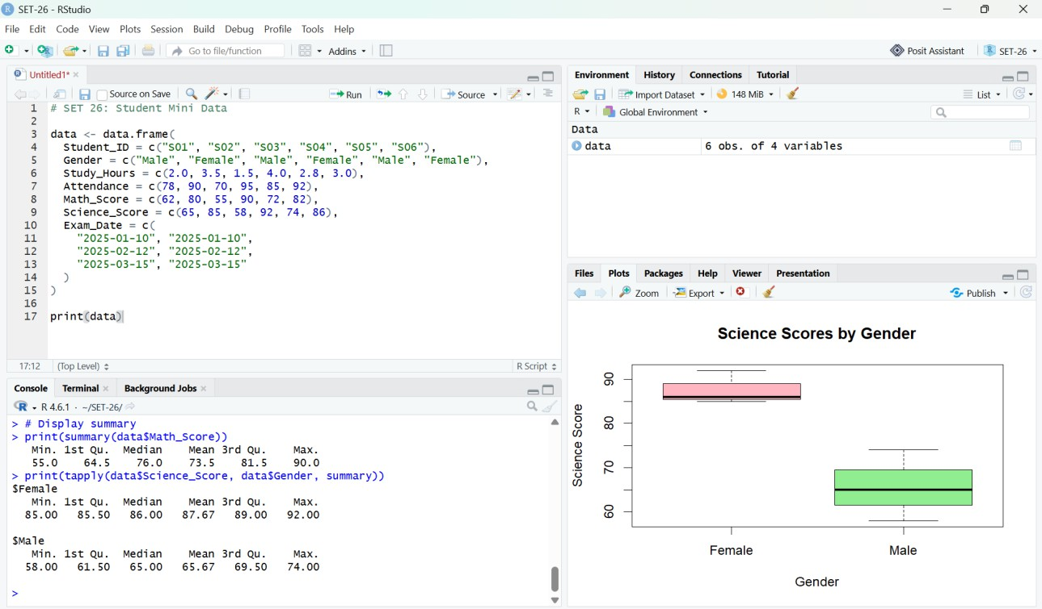
Figure 2. RStudio output: boxplot comparing science scores by gender.

PROGRAM 3: Monthly Average Mathematics Score Trend
To calculate monthly average mathematics scores and compare the observed averages with a two-month moving average.
# SET 26 - PROGRAM 3
data <- data.frame(
Student_ID = c("S01", "S02", "S03", "S04", "S05", "S06"), Math_Score = c(62, 80, 55, 90, 72, 82),
Exam_Date = as.Date(c(
"2025-01-10", "2025-01-10",
"2025-02-12", "2025-02-12",
"2025-03-15", "2025-03-15"
))
)

data$Month <- format(data$Exam_Date, "%Y-%m") monthly_avg <- aggregate(Math_Score ~ Month, data, mean) monthly_avg <- monthly_avg[order(monthly_avg$Month), ] moving_avg <- stats::filter(monthly_avg$Math_Score,
filter = rep(1/2, 2), sides = 1)

plot(seq_len(nrow(monthly_avg)), monthly_avg$Math_Score, type = "o", pch = 19, col = "blue",
xaxt = "n", xlab = "Month", ylab = "Average Math Score", main = "Monthly Average Math Score Trend",
ylim = range(c(monthly_avg$Math_Score, moving_avg), na.rm = TRUE))
axis(1, at = seq_len(nrow(monthly_avg)), labels = monthly_avg$Month) points(seq_len(nrow(monthly_avg)), moving_avg,
type = "o", pch = 17, col = "red") legend("topleft",
legend = c("Monthly Average", "2-Month Moving Average"), col = c("blue", "red"), lty = 1, pch = c(19, 17), bty = "n")
text(seq_len(nrow(monthly_avg)), monthly_avg$Math_Score, labels = round(monthly_avg$Math_Score, 1), pos = 3)
print(monthly_avg)

Procedure: Convert exam dates to month labels, aggregate the mathematics scores by month, calculate the two-month moving average, and plot both series.
Observation / Result: Monthly average mathematics scores are January = 71, February = 72.5, and March = 77. The averages rise across the three months. The moving average smooths the monthly values; with a two-month window, the first plotted value may be unavailable depending on the calculation convention.

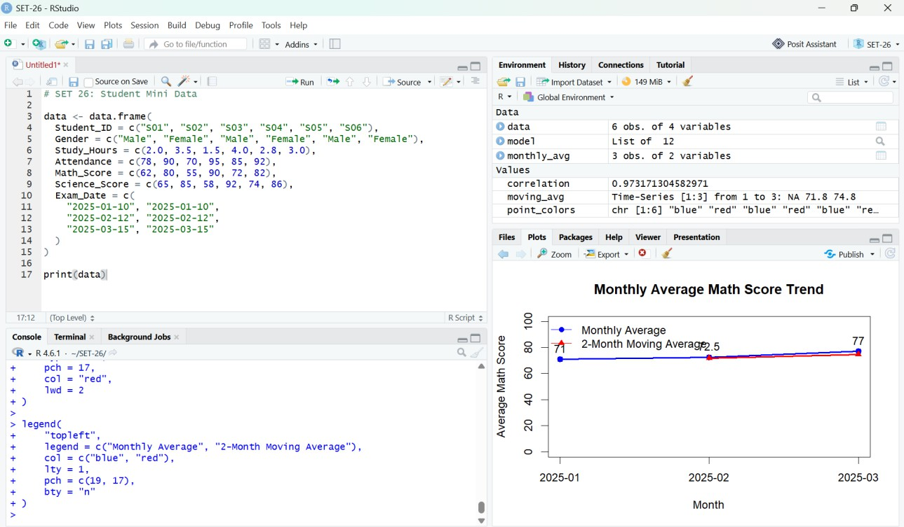
Figure 3. RStudio output: monthly average mathematics scores and two-month moving average.

Overall Procedure
- Enter the student dataset in RStudio using data.frame().
- Create a scatter plot, regression line, and correlation coefficient for study hours and mathematics scores.
- Create a boxplot and gender-wise summary statistics for science scores.
- Aggregate mathematics scores by month and plot the monthly averages with a moving average.
- Run each program and interpret the resulting charts and statistics.

Overall Result
Student performance was explored through a scatter plot with regression line, a gender-wise science-score boxplot, and a monthly mathematics-score trend. The supplied dataset showed a strong positive correlation between study hours and mathematics scores (approximately 0.973), higher mean science scores among the three female observations than the three male observations, and monthly average mathematics scores of 71, 72.5, and 77 for January through March 2025. These are descriptive findings from a very small dataset.

